Ideation Phase
Define the Problem Statements

Date | 13 July 2026
Team ID
Project Name | DarshanEase
Maximum Marks | 2 Marks

Customer Problem Statement Template:
Create a problem statement to understand your customer's point of view. The Customer Problem Statement template helps you focus on what matters to create experiences people will love.
A well-articulated customer problem statement allows you and your team to find the ideal solution for the challenges your customers face. Throughout the process, you’ll also be able to empathize with your customers, which helps you better understand how they perceive your product or service.
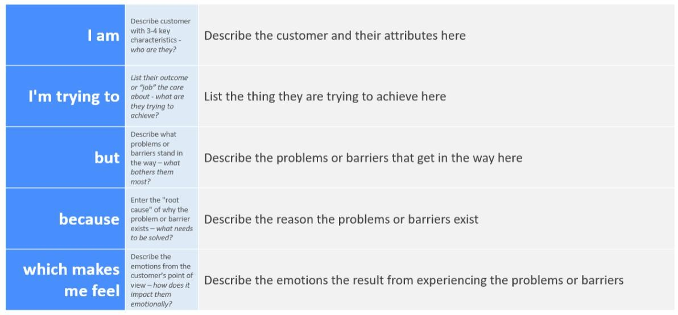
Reference: https://miro.com/templates/customer-problem-statement/

Example:
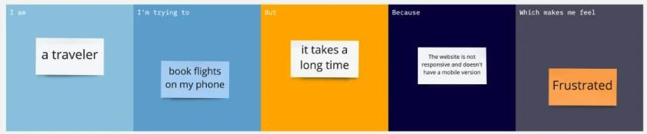

Problem  Statement (PS) | I am  (Customer) | I’m trying to | But | Because | Which makes me feel
PS-1 | A devotee planning to visit a temple | Book a Darshan slot in advance and have a smooth temple visit | I often face long queues and overcrow ded temples | There is no proper digital system to manage Darshan bookings or  crowd flow | Frustrated and uncertain about my visit
PS-2 | A devotee who wants temple information and donation options | Find temple details and donate online securely | I struggle to find reliable informati on and trusted online donation  platforms | Most temples rely on offline systems and scattered information sources | Confused and concerned

